CHATROOM SOFTWARE



**PROJECT MADE BY:**

**NAME: - JATIN YADAV**

**ROLL NUMBER: - 18**

**CLASS & SECTION: - 12TH A**

The "Chat room Application" has been developed to override the problems prevailing in the practicing manual system. This software is supported to eliminate and in some cases reduce the hardships faced by this existing system. Moreover this system is designed for the particular need of the company to carry out operations in a smooth and effective manner.

The application is reduced as much as possible to avoid errors while entering the data. It also provides error message while entering invalid data. This software saves all the record in a SQL database. Thus by this all it proves it is user-friendly. Chat room Application, as described above, can lead to error free, secure, reliable and fast management system. It can assist the user to concentrate on their other activities rather to concentrate on the record keeping. Thus it will help organization in better utilization of resources.

**introduction**

Functionalities provided by chat room application

1. One to one chatting by entering receiver’s user id

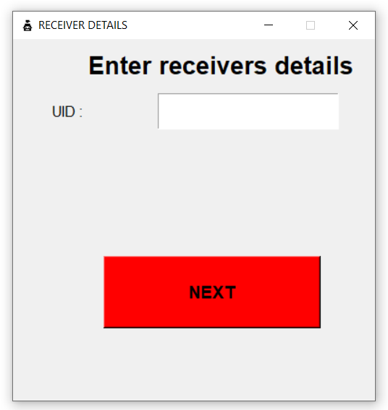

1. Chat history

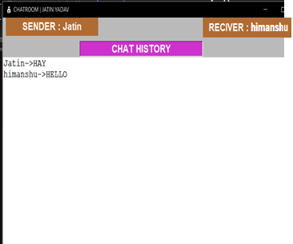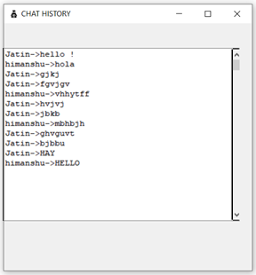

**GUI PAGES MANAGING PROGRAM**

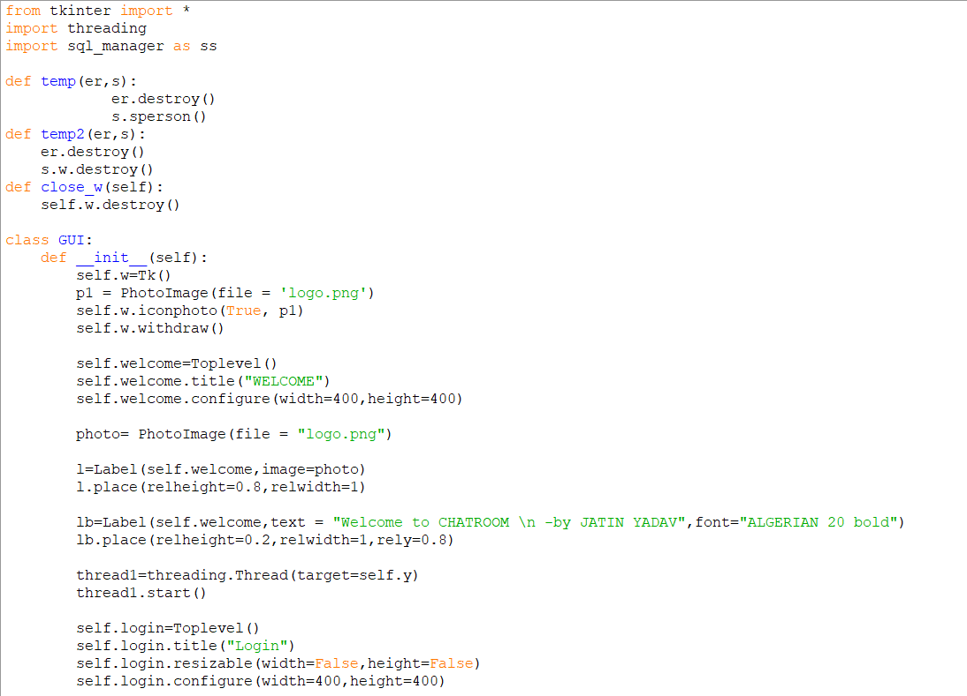 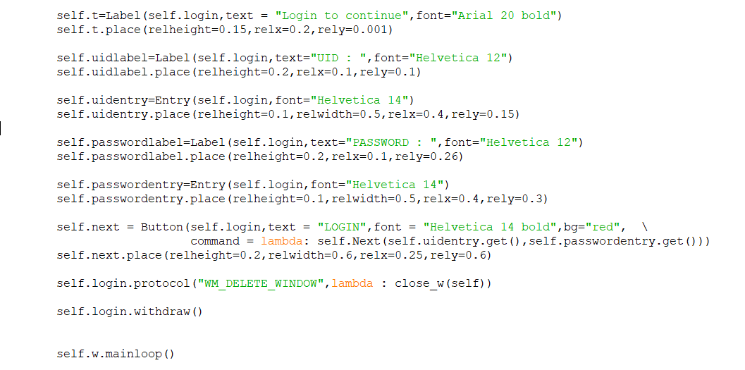

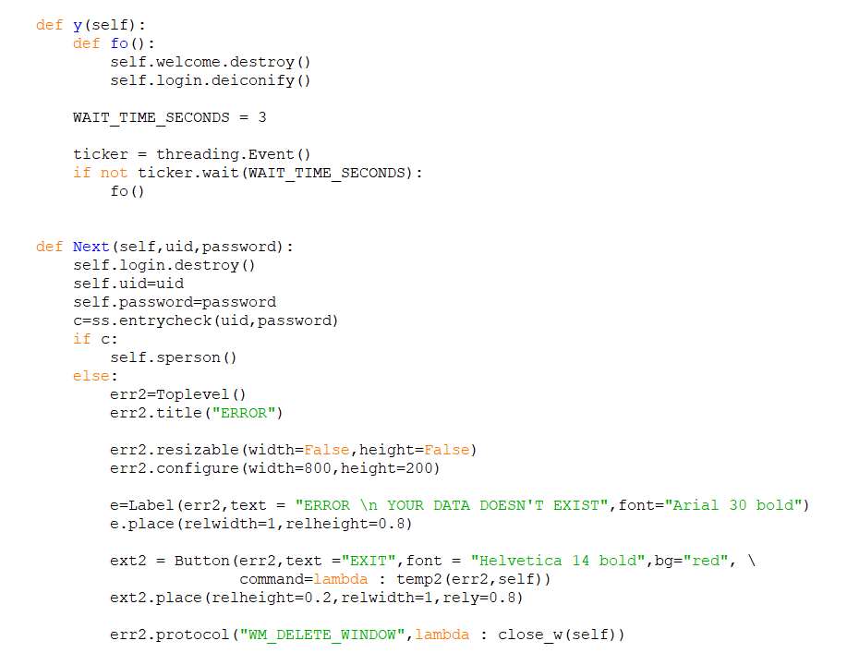

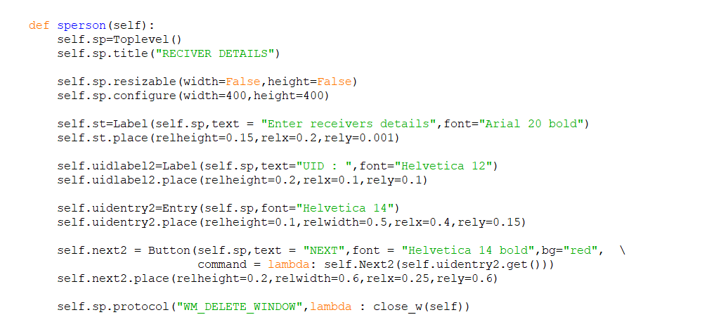

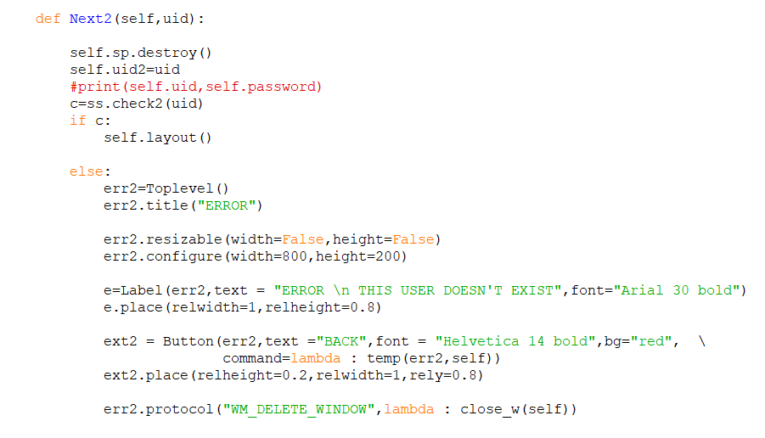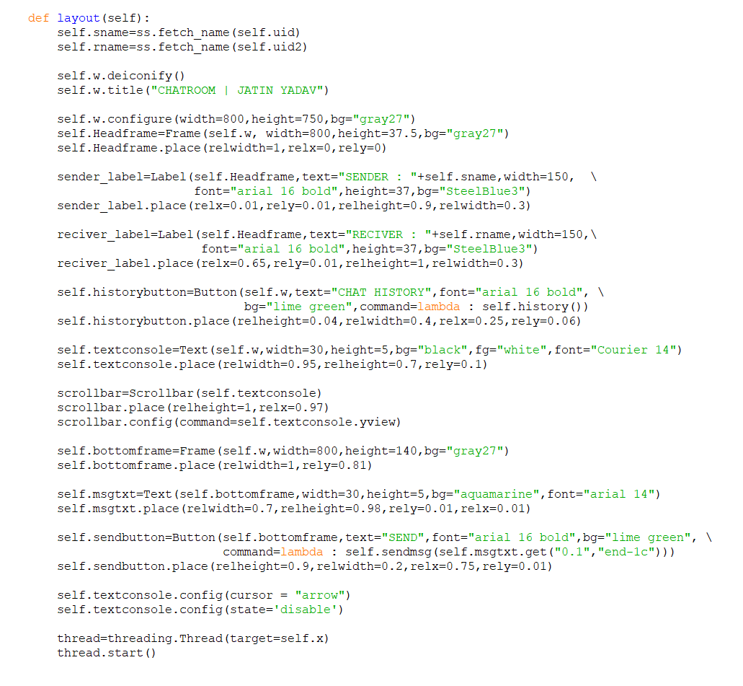

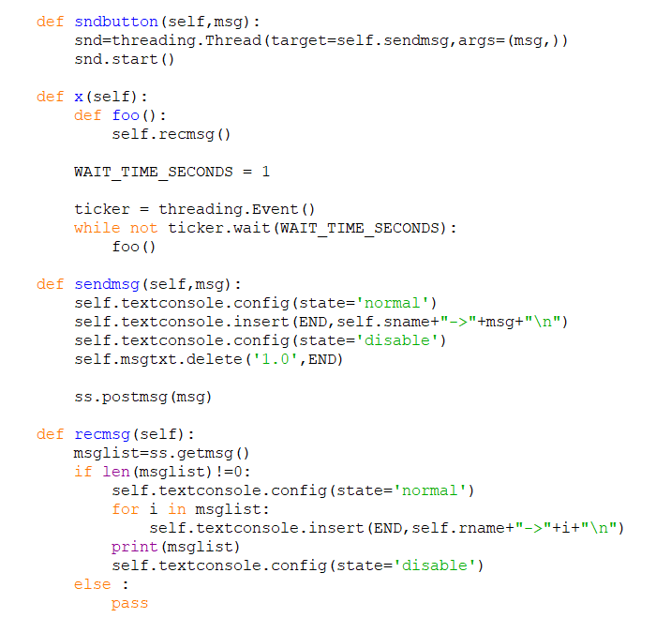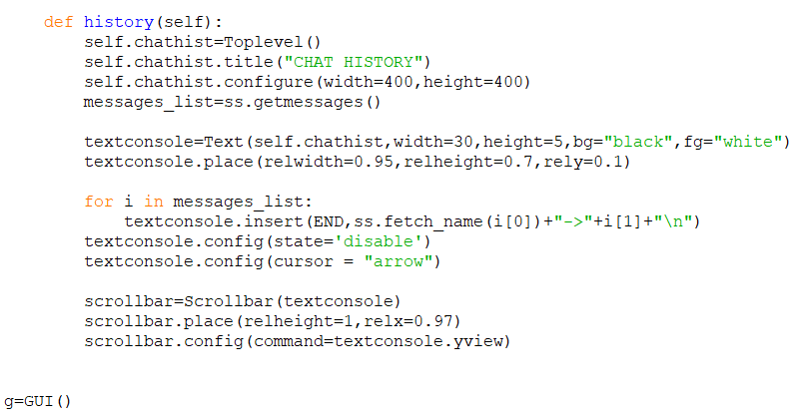

# SQL TABLES MANAGING PROGRAM

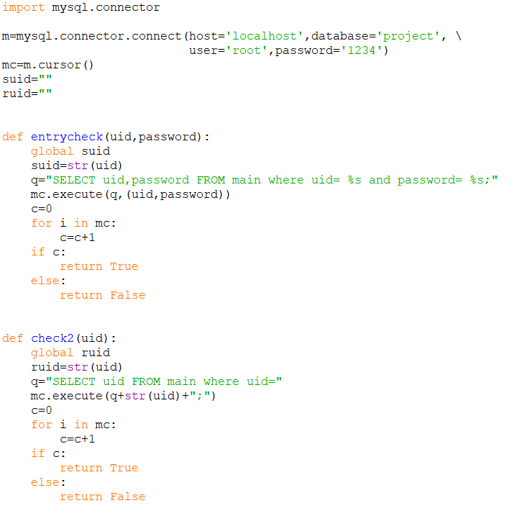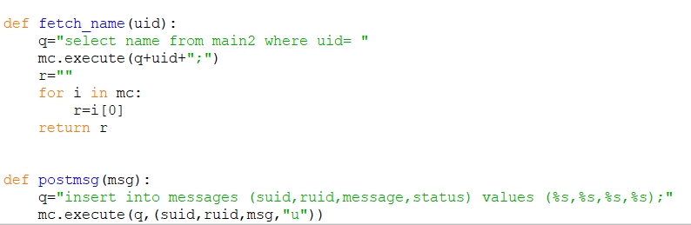

# SQL TABLES

DATABASE NAME: - project

No. of tables in project: - 03

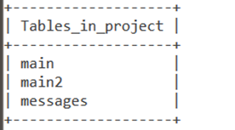

Content of table “main”:-

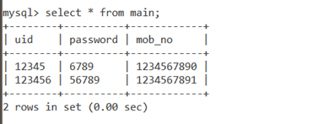

Content of table “main2”:-

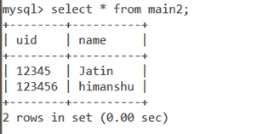

Content of table “messages”:-

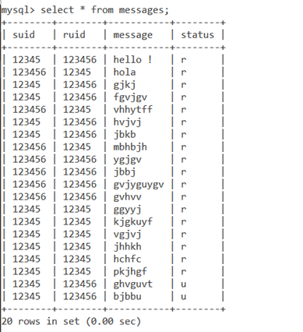

**PROGRAM EXECUTION**

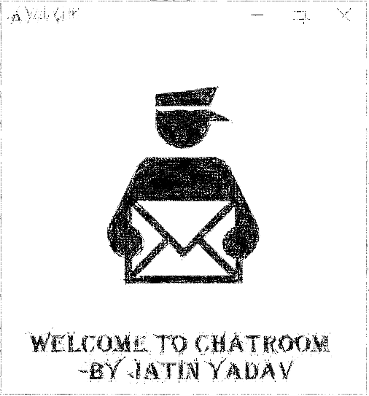

* ***Welcome window*** *@*
* ***Login Window***

1. ***Correct Functionality***
2. ***Error Window INCORRECT DETAILS***

* ***Receiver’s detail Window***

1. ***Error Window INVALID RECEIVER***
2. ***Correct functionality***

* ***Chat-Room Window***

1. ***Chat History***

**1.** **WELCOME WINDOW**

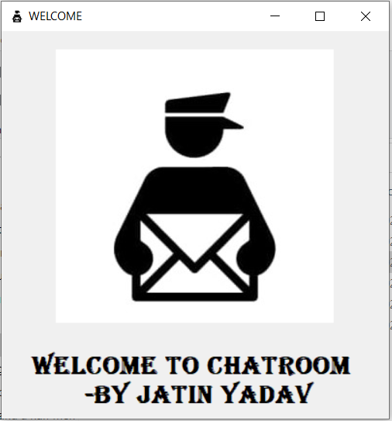

**2. LOGIN WINDOW**

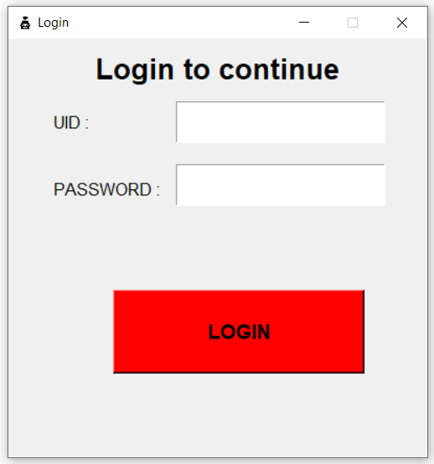

* **IF ENTERED INCORRECT DETAILS**

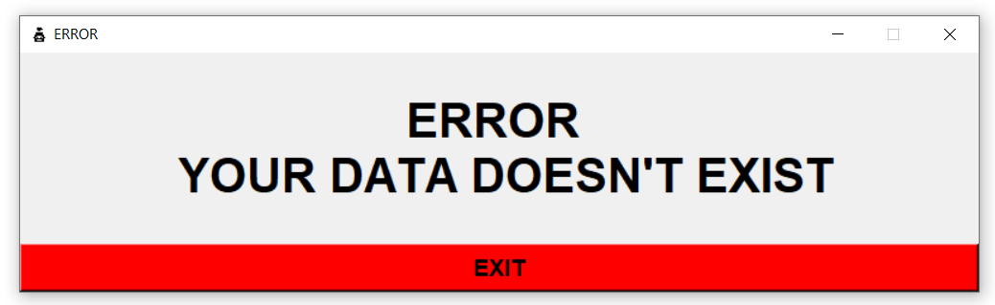

**3. RECEIVER’S DETAILS WINDOW**



* **IF ENTERED INCORRECT DETAILS**

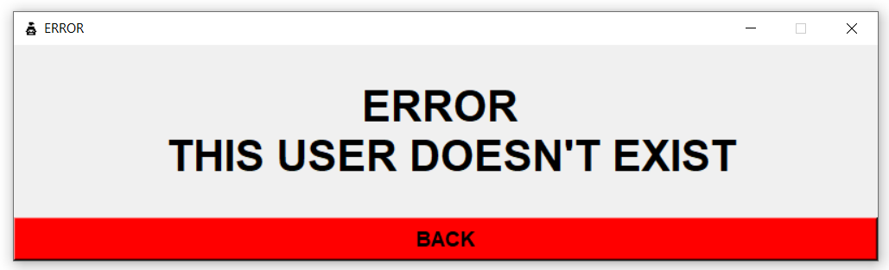

**4. CHATROOM WINDOW**

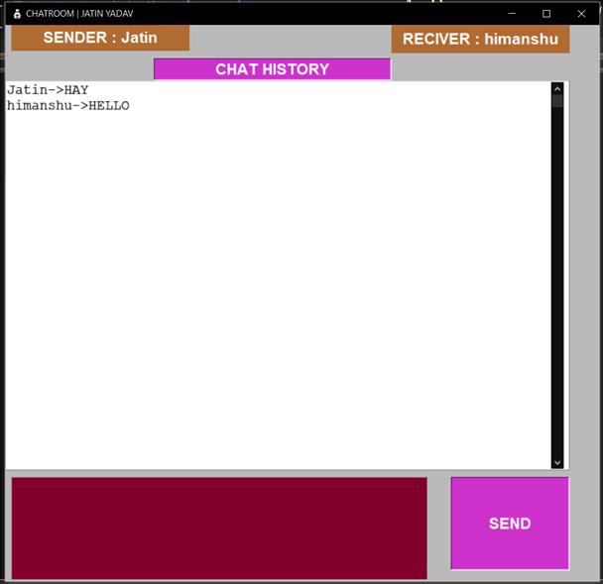

**THANK YOU**